ПОЯСНИТЕЛЬНАЯ ЗАПИСКА

В соответствии с предложенной единой темой для организации деятельности методических формирований учителей иностранных языков в 2024/2025 учебном году «Повышение качества образования средствами учебного предмета «Иностранный язык», в том числе в контексте формирования функциональной грамотности учащихся» были разработаны и систематизированы практико-ориентированные задания для формирования читательской грамотности.
Цель разработки:
- помочь учащимся правильно организовывать и анализировать информацию;
- сформировать и совершенствовать навыки читательской грамотности учащихся посредством использования практико-ориентированных заданий;
- интегрировать новые знания учащихся;
- систематизировать изученный материал;
- расширить объем изучаемого материала по английскому языку.
Критерии:
В основу разработки и создания дидактических материалов мною были положены требования к овладению следующими группами умений при формирование читательской грамотности:
- поиск и нахождение информации;
- интерпретация и интеграция информации;
- оценка содержания и формы текста;
- использование информации текста для решения практических задач.
Дидактические материалы были разработаны на основе национального учебно-методического комплекса «Учебное пособие для 11 класса учреждений общего среднего образования с белорусским и русским языками обучения (повышенный уровень)», авторы: Н.В. Демченко, Э.В. Бушуева, Т.Ю. Севрюкова, Л.М. Лапицкая, В.Р. Романчук.
Представленные материалы разработаны по разделу «Профессии» и представляют собой комплекс заданий согласно тематического содержания урока на базе представленных в учебном пособии текстах.

Lesson 2. Jobs: pros and cons
Exercise 2a page 47

Группа умений: находить и извлекать информацию
- Scan the QR code, study the information about Kevin’s job. Write questions about his company. Use different types of questions.
Application 1

- ………….
- ………….
- ………….
- ………….
- ………….

Группа умений: интерпретация и интеграция информации
- Read the text and mark the information as A) information about advantages and B) information about disadvantages. Pay special attention to words in italic.
I have been working as a barista full-time for more than a year, though anyone can ask the employer for flexible working hours. My company is a great place to make friends. This job offers a lot of perks such as an excellent health care package, a free pound of coffee a week and free drinks during the breaks; if you love coffee, here it is! The wage isn’t high – $8 per hour, but they give us overtime payment, all the holidays are paid. Moreover, if you run your business properly, you will be able to get a bonus every quarter. It’s important to me that the company appreciates its staff. In case employees show their commitment, they’re likely to get a promotion. As for the disadvantages of being a barista, it has long hours standing on your feet, dealing with rude customers, a lot of stress during the busiest time of the day and the Festival period sometimes makes the job backbreaking and stressful.

Advantages | Disadvantages
Группа умений: оценка содержания и формы текста
Salary is a fixed amount of money that you earn each month or year from your job. | ……………………………………………...
If you run your business properly our company pay you extra money in addition to your salary. | ……………………………………………...
There is always a chance of a moving to a higher position in a company. | ……………………………………………...
You can always be offered an extra benefit from employer. | ……………………………………………...
Don’t worry! Our organisation pays people who work for them in time. | ……………………………………………...
People who work in our company are paid regularly to work. | ……………………………………………...
- Replace the underlined word(s) with a word or phrase that has a similar meaning.

Группа умений: использование информации текста
для решения практических задач
- Do you think it is a good job to be a barista nowadays? Would you like to be a barista? Why (not)? Write your personal reasons to improve it. Use the lists of words.

Advantages | Disadvantages
well paid, prestigious, rewarding, challenging, satisfying, creative, secure, perks and bonuses, promotion, flexible hours, to work from home, regular / odd job, good working conditions, to work shifts, to work part-time. | badly paid, tiring, backbreaking, stressful, monotonous, repetitive, messy, need a lot of training, to require qualifications, poor working conditions, to work late / long hours, to work night shifts, to work full-time.

Lesson 2. Jobs: pros and cons
Exercise 4c page 49

Группа умений: находить и извлекать информацию
- Scan the QR code. Watch a silent video. Do the following tasks. Complete the table about the video.

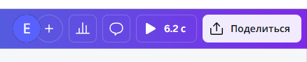

Application 2
Task 1. Guess the job by the video.
Task 2. What information is not mentioned in the video? Write the numbers.
JOB | WHAT INFORMATION IS EXTRA?
Civil Aviation pilot Flight attendant  Flight Engineer  Air traffic controller Airline Managers Customs officers | - having outstanding leadership skills; 2) flying for free for being an employee; 3) stressful job; 4) being responsible for creating a proper image of their company travelling around the world; 5) meeting friends from other countries; 6) making sure the computer system in a company works well; 7) spending time and holidays without family and friends; 8) learning about different countries and cultures; 9) being responsible for making financial analysis and giving advice on how to improve the company’s profits’; 10) making friends with other employees; 11) meeting celebrities; 12) changing plans; 13) mean passengers; 14) great benefits; 15) forced interaction with people

Группа умений: интерпретация и интеграция информации
- Look at the pictures and share your opinion on the following questions.








- What advantages can this job have?
- What problems do employees face?
Группа умений: оценка содержания и формы текста

- Listen to the text and complete it with necessary information (use exercise 1, task 2 if it is necessary).


The first advantage is obvious. You fly anywhere for free. This is just a perk that allows you to fly ……………………………………. . That’s an incredible …….... . It’s also a great chance to see ……………….. and visit friends. Moreover, it’s one of the most culturally diverse jobs. You can meet and befriend other flight attendants of every ……………….. . I’ve learnt so much about other …………….. and ………………. because I get to spend time with some really interesting people. Besides, I’ve had some really fascinating and delightful passengers. It’s never boring. Sometimes the tasks can become monotonous, but you’re never flying with the same people, you’re going to different places, there’s never a typical day. You can even meet ……………… . Doesn’t all of that sound awesome? In addition to all the great benefits listed above, flight attendants also ……………………….. . However, it takes some time and experience before you are one of the higher paid flight attendants.

Application 3

I cannot only present my job with rose-coloured glasses. It can be really, really hard. It’s important to know both sides of the coin. One of the disadvantages of being a flight attendant is that you have to ……………………… to holidays (for a while at least). Spending Christmas in a hotel by yourself is never going to be easy. Last year I was in Oregon for Thanksgiving, ……………… for Christmas, and Florida for ……..………………….. .
Another unpleasant thing is that your ……….. will always …………… . Your day will change with ………..…….. . I still hear horror stories from a couple of winters ago when people got stuck in New York for days because of the snow storms.
What is more, you miss a lot of what happens …………..….. . I’ve missed so many birthdays, so many parties. I’ve missed visits from my ……………..…….. and ………………….… because I’ve had to work.
This job is sometimes ………………….…… as people can be mean. As flight attendants, we’re sometimes the only face of the airline people get to ………………….….. with. This can be great, but it can also be tough. I hope it gives you a better idea of what it’s like. I think it always sounds like a fun and glamorous job, and it is often rewarding – but it can be equally challenging.

Группа умений: использование информации текста
для решения практических задач
- Imagine that you are a flight attendant. Make a list of your own advantages and disadvantages by classifying those that are mentioned in the text. Choose 2-3 and speak about them in details.

Lesson 4. English and career
Exercise 5a page 57
Группа умений: находить и извлекать информацию
- Look at the survey below. Do the following tasks.

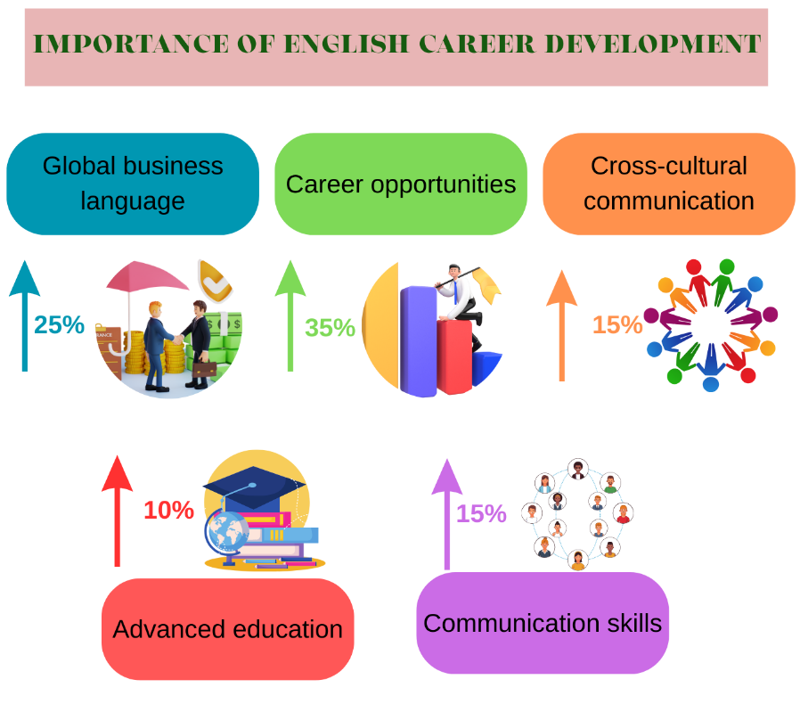
1. Give the answer to the following questions.
a) what the topic of the survey is;
b) what the objective is.


- Scan the QR code. Read about different types of questions.

- make questions to talk about importance of studying English for career;
- write these questions on a piece of paper;
- interview your classmates and write down their answers.

Application 4

Группа умений: интерпретация и интеграция информации
2.Look at the sentences and match them with their definitions.
Clear and effective communication is the important part of all successful business interactions. You need to be able to clearly articulate your ideas and opinions. | More career opportunities
Networking is a key component in the business world. If you want to be successful, then it’s important that you attend international events and conferences. By improving your English proficiency, you’ll open doors to more global networking opportunities. | Personal growth and confidence
Bilinguals typically receive salaries that are 5% to 20% higher than those who only speak one language. Besides being paid more, employees who speak English are more likely to be considered for international assignments | Better communication skills
Learning English will undoubtedly give you a boost in your professional life, but let’s not forget the effects that it’ll have on your personal life too! Having a high level of English means you can communicate with people while travelling. | Networking and collaboration

Группа умений: оценка содержания и формы текста
- You are going to read four extracts from the forum in which people give interviews about importance of learning English. For questions 1-13, choose the text (A-D). One text may be chosen more than once.
A
English helps stand first in competition. In a nutshell, English is the oxygen that keeps the professional life very strong and agile. English is indispensable to one’s success. It is a language of prominence in the professional world. The importance of English begins at the threshold of the professional world.
B
The person with necessary interpersonal skills and decent communication skills can impress a client right at the beginning of any business deal. Good communication skills in English are mandatory for successful seminars and presentations. If you are able to express yourself effectively, you are halfway towards success in your career.
D
Knowledge of English becomes mandatory in any given situation of life. Therefore, it is highly suggested to realize sooner than later the importance of learning English. English opens brilliant career vistas in which one could stroll and relax elegantly. On the other hand, career prospects become limp in a situation where English takes a back seat.

C
Competitive examinations make learning English even more indispensable. The journey with English in a situation like this is almost right from birth to all the major and quintessential phases of life. Studying abroad now requires knowledge of the English language. If the level of language is not up to the mark, then getting a high score in international exams will be next to impossible. In other words, it can be said that the dream to study in an English country will be shattered to pieces just because of the poor language skills.

In which text does the person:

say that success in competitions depends on your English level? | 1
say that language skills could give the opportunity to travel? | 2
say that learning English improve your career opportunities? | 3
say that you should have appropriate communicative skills for a job? | 4
say that English language skills can benefit you? | 5
say that you could get ahead of other candidates applying for a new job? | 6
say that speaking English opens up a wide range of opportunities in your career? | 7
say that showing you’ve learned English show employers that you’re dedicated? | 8
say that learning English you get many chances to show your skills in competitions? | 9
say that you could practice English in your workplace environment? | 10
say that English is a global business language? | 11
say that the ability to express yourself in language can boost your self-assurance in social settings? | 12
say that effective communication are highly transferable? | 13

1 | 2 | 3 | 4 | 5 | 6 | 7 | 8 | 9 | 10 | 11 | 12 | 13

Группа умений: использование информации текста
для решения практических задач
- Conduct a survey according to the task 1 (2). Analyse your classmates’ answers. Make the presentation of the results using the expressions below.
- Giving your opinion
In my opinion, ... I
t seems to me that…
- Starting an interpretation
The survey indicates…
These data show that…
From the results obtained, it seems that…
The results of this survey reveal that…
- Comparing results
In relation to (our group)…
The gap between group 1 and group 2 is significant!
The difference is minimal / small / negligible.
4. Summarizing the information
0–20% Almost no one thinks that…
0–50% Less than half of the class said that…
(40%)–50% (Almost) Half of the respondents…
More than 50% / The majority of the class / Most people... / A large number believe that…
100% / The whole class / everyone…

Lesson 3. Choosing a career
Exercise 2a page 51

Группа умений: находить и извлекать информацию
- You are going to read a magazine article in which people give opinions about factors that influence a career choice. Complete the passage with missing information.

1 | 2 | 3 | 4 | 5

A | They might see talents that parents or students themselves might overlook.
B | It portrays different jobs under different lights; some are viewed as more glorious than others.
C | This is common with people who are in group chats and social media groups who have a mindset that the majority choice is the best. Many students who follow this part fail to succeed because they choose what others want, not what they are good at.
D | Figure out where your career interests are by asking yourself.
E | for a living; where they live; their education, knowledge and skills; how much they earn; and how they spend their time and money.
Группа умений: интерпретация и интеграция информации
- Work in pairs and do the following tasks.
Task 1. Scan the text.


Application 5
Task 2. Entitle your passage using the following headlines.
Teachers / Career adviser
Media and information
Self-assessment
Friends and classmates
Family

Task 3. Formulate the main idea of every passage in one-two sentences.
Task 4. Find the English equivalents to the following word combinations: подходить, влиятельный, пропустить, сверстник, стремление, идти по стопам родителей, зов.
Task 5. Complete the table with necessary information.

№ | Headline | The main idea | Equivalents
Text 1 |  | The main factor that influence a career choice according to this text is …
Text 2
Text 3
Text 4
Text 5

Группа умений: оценка содержания и формы текста
- Evaluate arguments of the “How to make a career choice?” article by completing the table.

Criteria | Fully agree | Partially agree | Disagree
Many students are usually in a fix when it comes to choosing a career.
They are confused and don’t know the right way to go about it.
Nobody can influence on a teenager’s career decision.
The main influencers that affect a young person’s decision-making are immediate surrounding.
Parents are the most important influencers on a young person’s career decision.
Choosing a career choice by parents is common among parents who feel they know better than their children.
Students don’t wish to follow what the society wants.
It’s common to see students following their friends and classmates in their job selections.
Not all students can identify what their strengths are.
To know their potential many students look at the things they are good at and realize what they want.
Sometimes people choose “ideal” lifestyles from the film industry that many follow, and in many cases it is the right fit for everyone.
Careers advisers in schools never offer resources and guidance.

Группа умений: использование информации текста
для решения практических задач

4. Do you think it is important to consider different factors choosing a career? Write your personal reasons for the magazine “Jobs news”. Describe 3-4 main factors for you.

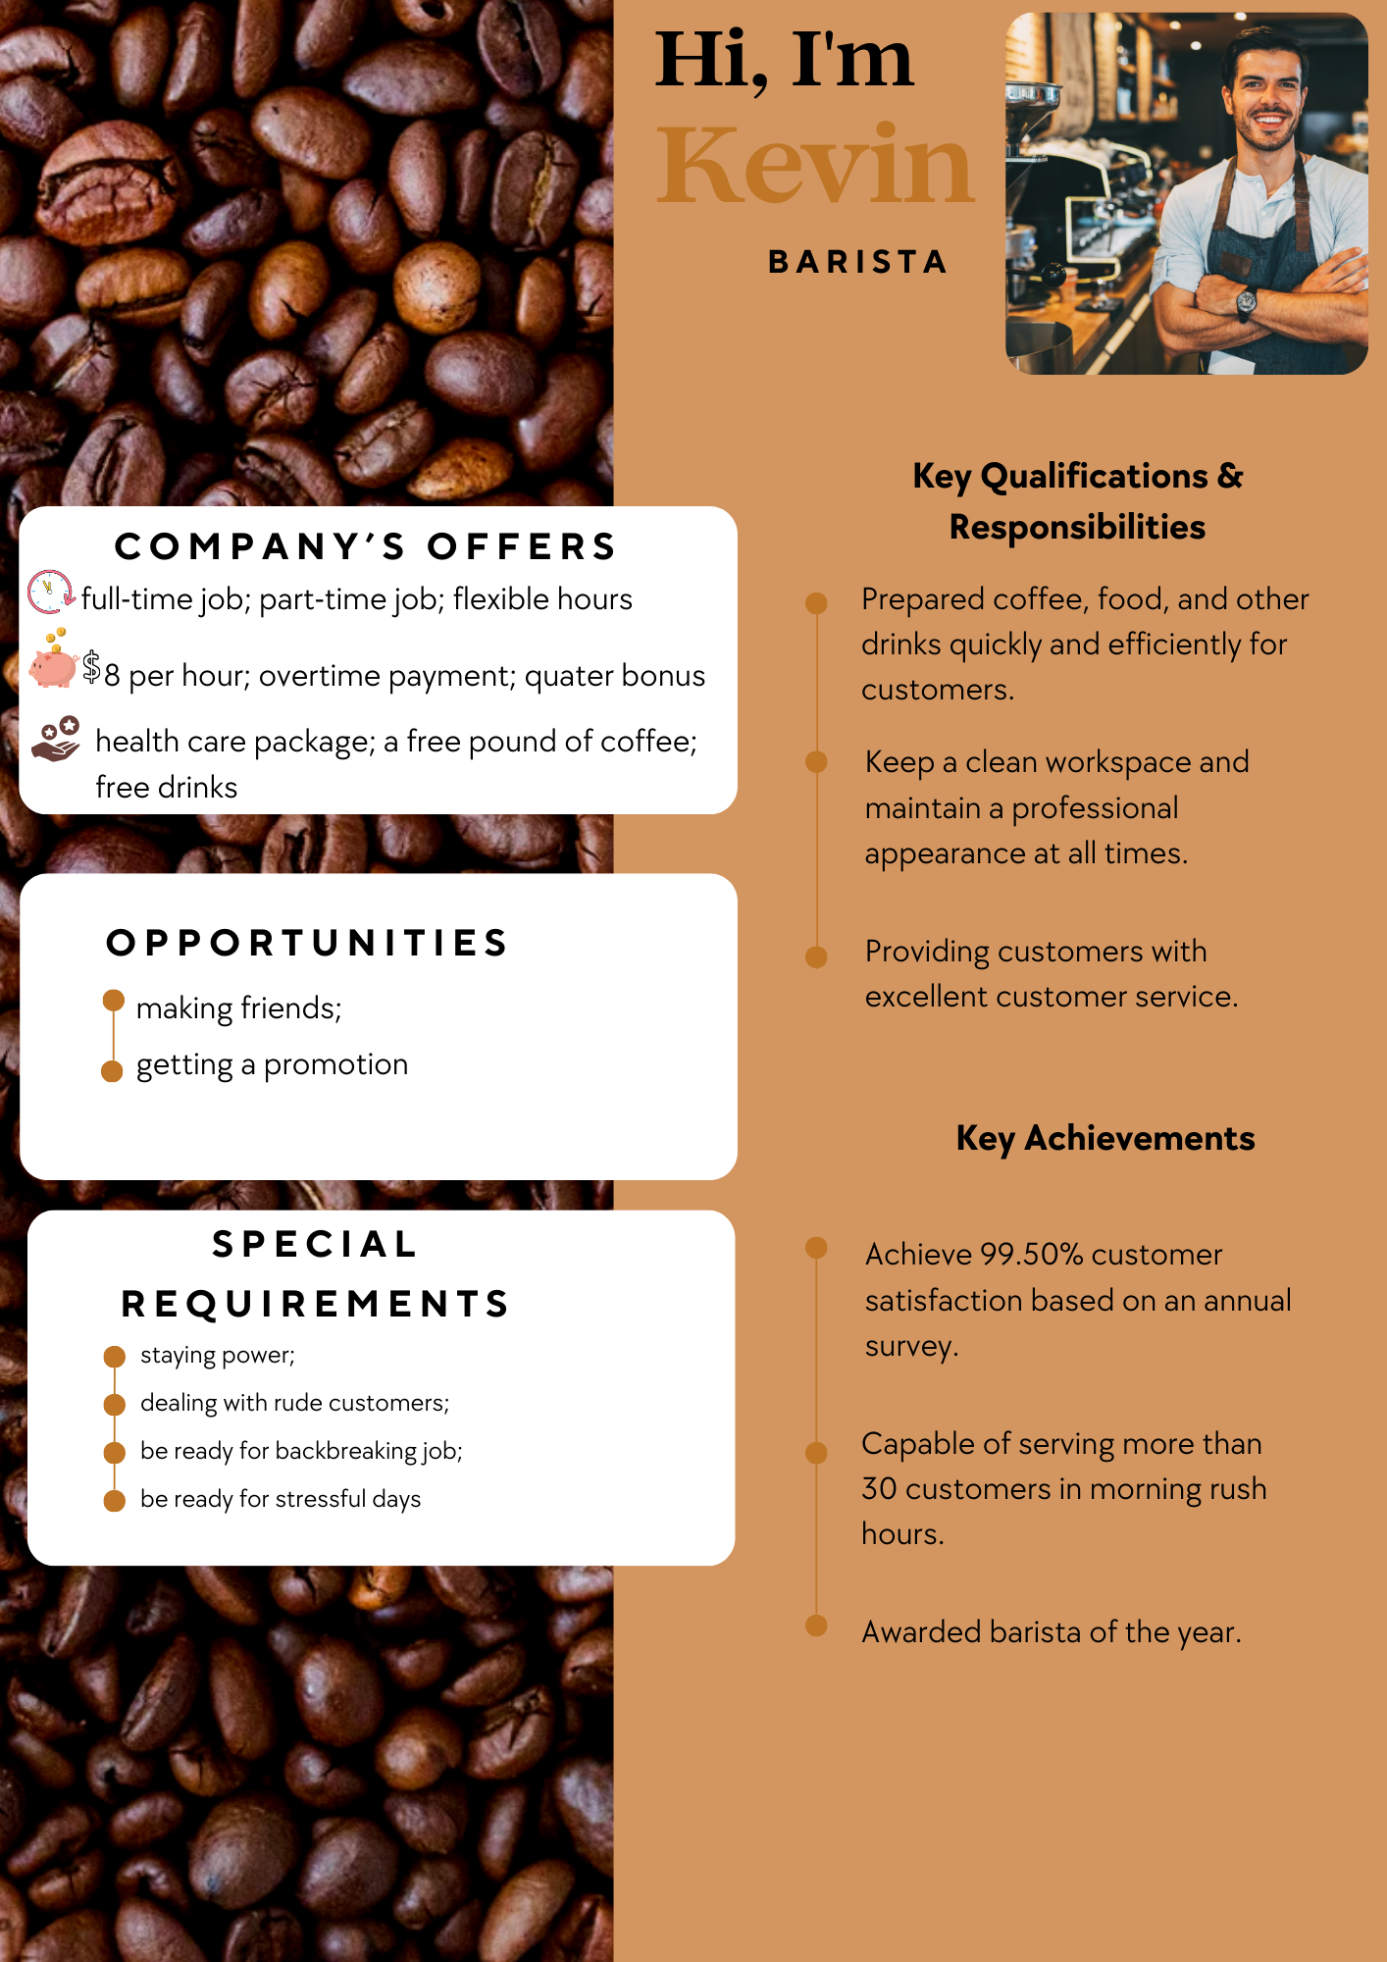
Приложение 1
Приложение 2

Приложение 3



Приложение 4

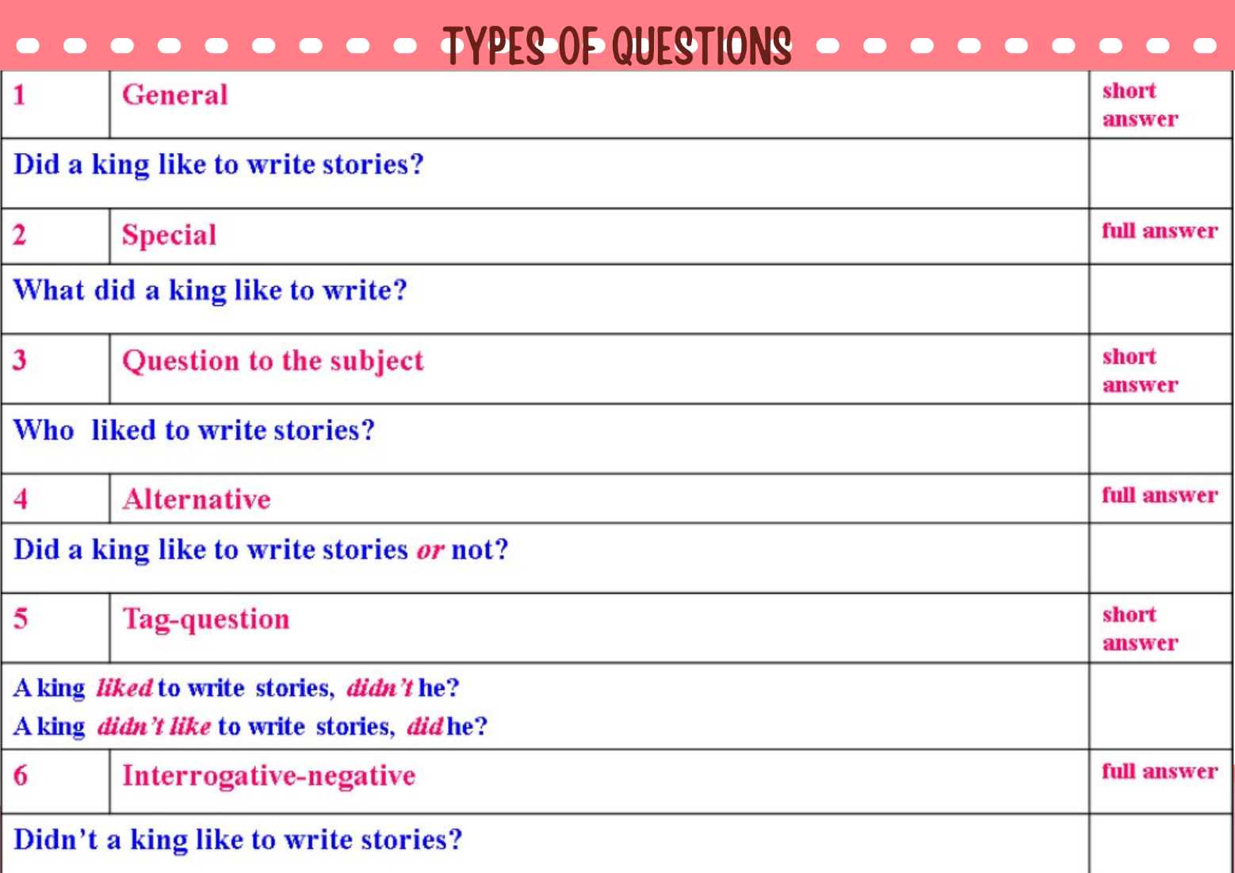


Приложение 5

